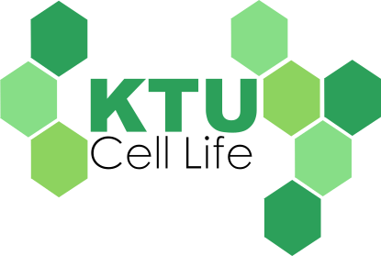

Module Instructions, Worksheet Keys, &

Supplemental Material

This work was supported in part by the following grant: NSF #MCB - 1330180



Welcome, Instructors and Parents, to The Virtual Kids’ Tech University is to improve literacy in primary math and science education to ensure a strong STEM workforce for tomorrow. The Virtual Kids’ Tech University targets elementary and middle school students at a critical point in their education and introduces Virginia Math and Science Standards of Learning through online games, lessons, and quizzes. Current expansion of previous KTU modules has led to the development of a multi-faceted cell game, *Cell Life*. By harnessing the developmental process of exploration, *Cell Life* presents concepts of cellular physiology in an approachable and entertaining manner. The culmination of resources provided within each module facilitates both a formal educational lesson as well as a home-based learning experience, exposing students to previous, current, and upcoming standards of learning.

**Introduction**

**Skills and Standards of Learning**

The material present in KTU’s *Cell Life* is formatted in correspondence with the Virginia Math and Science Standards of Learning and Key Concepts. This module was primarily designed to act as a supplement to in-class curricula and incorporates the following **Matter, Living Systems, and Cells** Virginia Standards of Learning:

*Investigate and understand that organisms are made of one or more cells and have distinguishing characteristics that play a vital role in the organism's ability to survive and thrive in its environment*

* SOL 5.5, a, b, c

*Investigate and understand that all living things are composed of cells. Key concepts include:*

* LS.2 a, b, c, d

*Investigate and understand that interactions exist among members of a population. Key concepts include:*

* LS.7 a, b

*Investigate and understand that organisms reproduce and transmit genetic information to new generations. Key concepts include:*

* LS.12 a

*Investigate and understand that living things are part of a system. Key concepts include:*

* SOL 2.5 a,c

*Investigate and understand that adaptations allow animals to satisfy life needs and respond to the environment*

* SOL.3.4 a,b

**KTU Components**

Incorporated into all of the Kids’ Tech University modules are the following components. In combination with the KTU website, these additional resources provide further lessons for students, which assist in reaching a deeper level of understanding for the material covered. These lessons can be used as a classroom supplement at all levels as a prerequisite, current lesson, or review. The following descriptions of these resources are tailored to the *Cell Life* module:

|  |  |  |
| --- | --- | --- |
| Interactive Games | Teacher Resources | Applied Lessons |
| *A series of strategy-based educational games illustrating the concepts of cellular physiology. Additionally, each of the games within the module present trivia questions covering the associated standards of learning.* | *The associated teacher manual covers the standards of learning addressed, additional module instructions to help students, as well as answer keys to the student packets provided.* | *The additional activities provided in the student packet work together with the KTU interactive games to provide a useful & applied learning experience. These activities can be referenced later as a useful guide when revisiting the information!* |

**Instructions**

The goal of the virtual Cell Life game is to explore a eukaryotic cell and discover each of its organelles. After winning each subgame and answering trivia at the end of the level, the player can gain new organelles for the main cell. Students will explore these critical life science concepts through the perspective of the cell gaining new organelles and learning to survive. By using the computer arrow keys to move around the petri dish, the player can collect tokens. These tokens will unlock a different subgame and trivia to explore a new organelle each time! In order to gain the new organelle for the main cell in the petri dish, the player must win the subgame and correctly answer the trivia.

The guide information bubbles that appear throughout the game will direct the player on how to move within their cell, return to the main KTU menu, adjust volume, zoom in/out of the main cell, and discover new organelles through the subgames. If at any time the player wishes to restart the organelle level or return back to the main cell, the blue “Quit Level” button is always located in the bottom left hand corner of the subgame screen.

The player will be prompted with specific directions before the beginning of each new game as well as at the end of the level. Be sure that the player carefully reads these instructions before proceeding to play the subgame. After the player has won each subgame, they will be given information on the organelle that has been unlocked. It is VERY important that the player reads this information thoroughly because they will immediately be given trivia following! The trivia uses only the information provided in the “You’ve Uncovered…” bubble (which appears as soon as they complete the subgame) to test the player. This trivia will incorporate multiple-choice questions and provides immediate feedback descriptions as to why the student’s answer choice was either correct or incorrect. Once the player has successfully won the subgame and completed the trivia, they will be taken back to the main cell. This main cell will incorporate the new organelle that the player unlocked. Through this process, players will gain an understanding of how each organelle helps the cell and see where the organelles appear within the cell!

Once the player has completed the subgames and collected all of the organelles for their main cell, they will unlock those organelle levels and can return to replay them at any time. Each correctly answered trivia question during the subgames will gain the player a star for that level. If every trivia question is answered correctly, the player can potentially gain 3 stars for each subgame level. These stars can be used to help later on during Trivia Madness, which will see how many *Cell Life* questions the player can answer within 60 seconds. This acts as a final review for the player, to further solidify their knowledge of the material covered!

**Instructor Key**

After the conclusion of the online module and Trivia Madness, please have students complete the following applied learning worksheets to practice the skills they have just learned. The following pages include all of the answer keys to the additional learning activities provided to students in the Cell Life module packet. Correct answers have been highlighted in red.

**Organelle Fill-In-the-Blank**

|  |
| --- |
| Macintosh HD:Users:h2ogirlswims:Desktop:Cell 1 [cytoplasm].png  The **Cytoplasm** a gel-like fluid inside of the cell made from water and nutrients that the cell uses. This is what keeps the cell’s organelles in place. |
| Macintosh HD:Users:h2ogirlswims:Desktop:Membrane.png  The **Cell Membrane** is similar to a gate that separates the inside of the cell from the environment outside of the cell. This organelle protects the cell from intruders by letting some things in but keeping other things out. |
| Macintosh HD:Users:h2ogirlswims:Desktop:Nucleus.png  The **Nucleus** acts like the cell’s brain. Inside this organelle is the cell’s genetic material (DNA). DNA acts like a blueprint for the cell with all of the directions for how to stay alive and reproduce. |
| Macintosh HD:Users:h2ogirlswims:Desktop:Ribosome.png  Macintosh HD:Users:h2ogirlswims:Desktop:Ribosome.pngThe **Ribosomes** use special instructions (DNA) to build proteins that help the cell do all kinds of tasks to stay alive!  Macintosh HD:Users:h2ogirlswims:Desktop:Ribosome.png |
| Macintosh HD:Users:h2ogirlswims:Desktop:ER.png  The **Endoplasmic Reticulum** has two parts: The **Smooth ER** makes lipids (fats) and breaks down toxins. The **Rough ER** has ribosomes attached to it, which make it “rough”. These ribosomes help the ER assemble proteins. |
| Macintosh HD:Users:h2ogirlswims:Desktop:Golgi.png  The **Golgi Apparatus** is like the cell’s very own post office. Materials are sent here to be modified, sorted, and packaged. These materials are then delivered to different places inside and outside of the cell! |
| Macintosh HD:Users:h2ogirlswims:Desktop:Mitochondria.png  The **Mitochondrion/Mitochondria** acts like the “Power plant” for the cell. This is because it creates energy by changing sugar into ATP! The cell uses this ATP as a special type of energy for its many jobs. (1 glucose 🡪 38 ATP) |
| Macintosh HD:Users:h2ogirlswims:Desktop:Lysosome_outlined.png  **Lysosomes** are made of sacs with substances inside of them that break down old organelles and other materials that the cell can’t use anymore turn them into new things that the cell can use! |

**Organelle Matching**

Use the word bank at the bottom to match the correct organelle name to each part of the cell diagram! You should only use each word once to complete this activity.

**F**

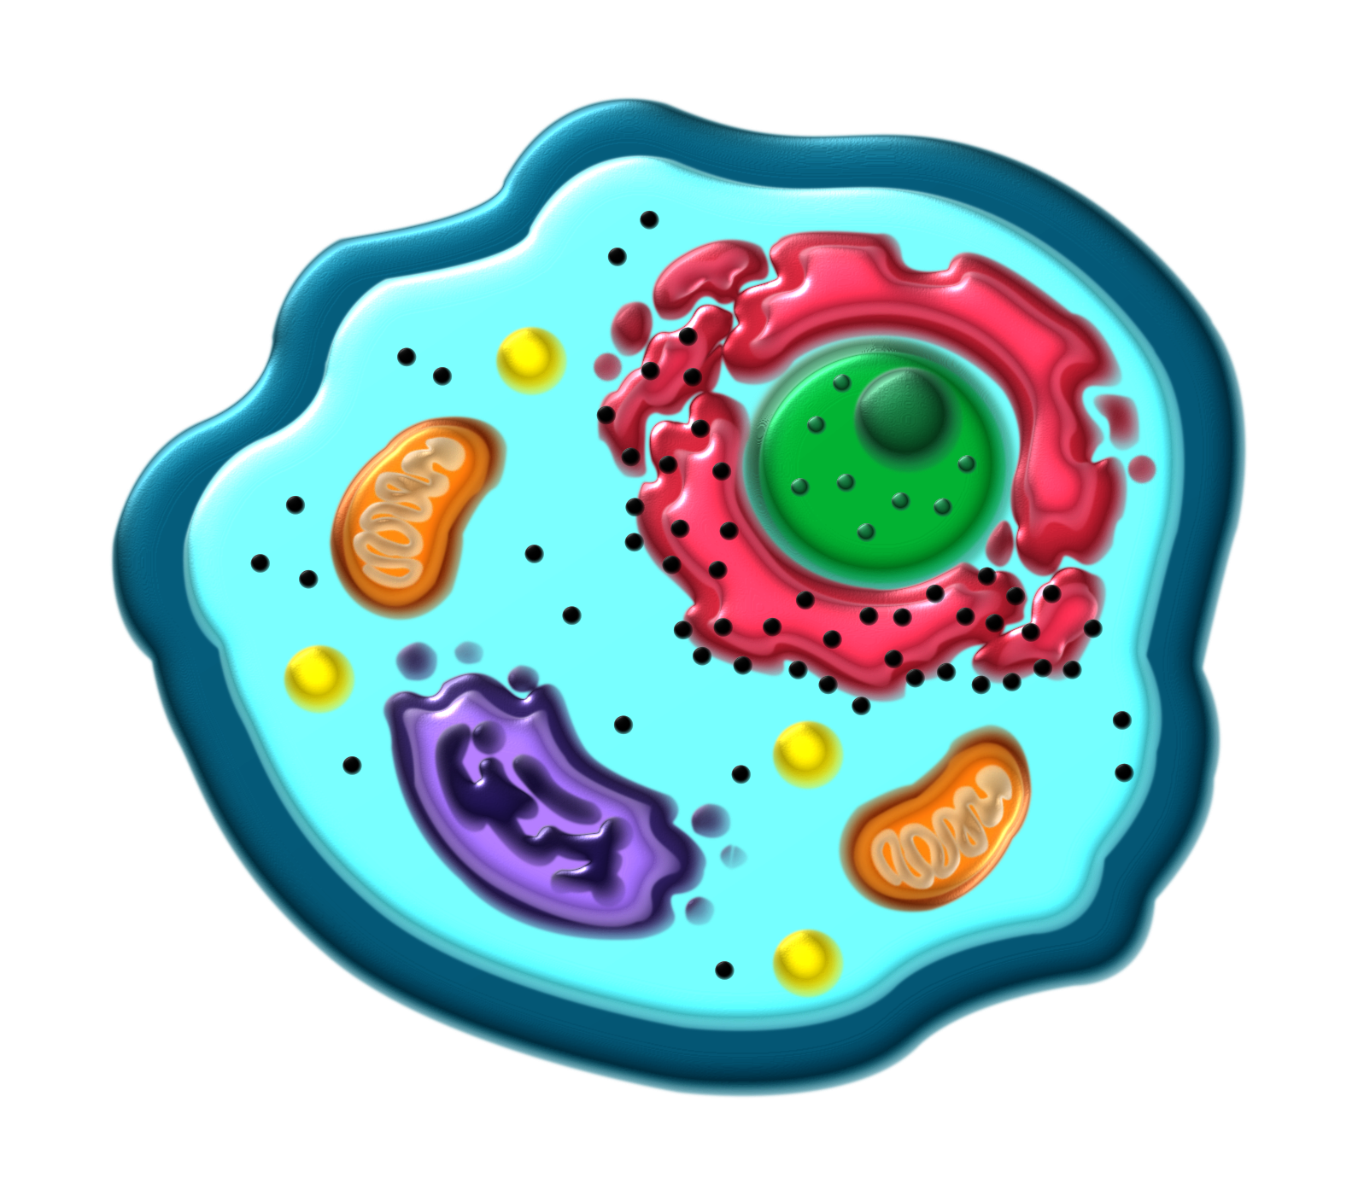

**D**

**A**

**H**

**C**

**G**

**E**

**B**

|  |  |
| --- | --- |
| **A.** Mitochondria | **E.** Golgi Apparatus |
| **B.** Cell Membrane | **F.** Lysosome |
| **C.** Ribosome | **G.** Cytoplasm |
| **D.** Endoplasmic Reticulum | **H.** Nucleus |

**Trivia Recall**

1. Which of the following is NOT a job of the Cell Membrane?
   1. Protect the inside of the cell from the outside environment
   2. Block everything that tries to leave the cell
   3. Control what goes in and out of the cell
   4. Keep the cell safe from intruders
2. The Endoplasmic Reticulum is made up of a series of:
   1. Cell Walls
   2. Organisms
   3. Cells
   4. Membranes
3. What does the Golgi Apparatus organize?
   1. Genetic Information
   2. Proteins
   3. Base Pairs
   4. Viruses
4. What is the main job of Lysosomes?
   1. Break down worn-out organelles and other materials the cell can’t use anymore
   2. Store information for the cell
   3. Block invaders from entering the cell
   4. Produce proteins
5. What is the Mitochondrion often called?
   1. The “Organizer”
   2. The “Underdog”
   3. The “Recycler”
   4. The “Powerhouse”
6. What is inside the cell’s Nucleus?
   1. Chloroplasts
   2. Lysosomes
   3. New Organelles
   4. DNA
7. What do Ribosomes make?
   1. Vesicles
   2. Lipids
   3. Proteins
   4. Waste
8. What is the Cytoplasm in a cell usually made of?
   1. Water and Nutrients
   2. Nutrients and Gelatin
   3. Water and Acid
   4. Electricity and Proteins
9. Which of these covers the rough Endoplasmic Reticulum?
   1. Chromosomes
   2. Viruses
   3. Ribosomes
   4. Bacteria
10. How are proteins transported to and from the Golgi Apparatus?
    1. Chloroplasts
    2. Cell Walls
    3. Vehicles
    4. Vesicles
11. What is inside of Lysosomes that help them do their job?
    1. Fat Cells
    2. Ribosomes
    3. Lactic Acid
    4. Digestive Enzymes
12. What does the Mitochondrion make that gives the cell energy?
    1. DNA
    2. RNA
    3. ATP
    4. AEM
13. The Nucleus of a cell acts like which of these?
    1. The “Brain” of the cell
    2. The “Defender” of the cell
    3. The “Food” of the cell

The “Powerhouse” of the cell

14. Where are Ribosomes made?

* 1. The Golgi Apparatus
  2. The Nucleus
  3. The Cell Membrane
  4. Outside of the Cell

1. What is one way that Cytoplasm helps the cell?
   1. Tells the cell what jobs to do
   2. Creates energy for the cell
   3. Helps to keep organelles from shifting out of place
   4. Recycles worn-out organelles
2. The \_\_\_\_\_\_\_\_\_\_\_\_\_\_\_\_\_\_\_\_\_\_\_\_\_\_\_\_\_\_\_\_\_ Endoplasmic Reticulum makes lipids (fats) for the cell.
   1. Smooth
   2. Complex
   3. Rough
   4. Long
3. Which of the following is NOT a way the Golgi Apparatus handles proteins?
   1. Packages
   2. Modifies
   3. Destroys
   4. Organizes
4. True or False – Lysosomes can use the materials they break down to create new things for the cell to use.
   1. True
   2. False
5. Which of these fuels helps the mitochondrion to make energy for the cell?
   1. Iron
   2. Glucose
   3. DNA
   4. Light
6. How does DNA help the cell?
   1. It provides energy for the cell to move
   2. It provides directions, like blueprints, for the cell to use to stay alive and reproduce
   3. It provides information about other cells
   4. It provides additional cells
7. What do Ribosomes use to make Proteins?
   1. Copies of the cell’s DNA
   2. Carbohydrates
   3. Extra Organelles
   4. Leftover Cellular Nutrients